PSG COLLEGE OF TECHNOLOGY, COIMBATORE – 641 004
Department of Applied Mathematics and Computational Sciences
MSc SOFTWARE SYSTEMS – Semester IV
20XW48 – Web Designing Lab
PROBLEM SHEET 6 – CSS3 Layouts & Positioning

- Make a layout template that contains a header and two paragraphs. Use float to line up the two paragraphs as columns side by side. Give the header and two paragraphs a border and/or a background color so you can see where they are.
<html>
<head>
<style>
body{
margin: 50;
padding: 50;
}

header{
color: aliceblue;
background-color: rgb(32, 82, 173);
}

p{
float: left;
width: 49%;
border: 1px solid;

}

.para1{
background-color: rgb(168, 198, 255);
}

.para2{
background-color: rgb(218, 231, 255);
}
</style>
</head>
<body>
<header>KPOP</header>
<p class="para1">Fav BGs:<br>SKZ, BTS, NCT, EN-, ATEEZ, TXT, etc</p>
<p class="para2">Fav GGs:<br>Dreamcatcher, Twice, Itzy, AleXa etc</p>
</body></html>

- Design a web page with four paragraphs. Apply a different border style and background to each paragraph using CSS code.
<html>
<head>
<style>
.zhongli{
border: 2px dotted rgb(231, 200, 114);
background-color: blanchedalmond;
}

.kaeya{
border: 2px inset rgb(114, 198, 231);
background-color: rgb(205, 252, 255);
}

.beidou{
border: 2px dashed rgb(165, 114, 231);
background-color: rgb(239, 205, 255);
}

.ningguang{
border: 2px outset rgb(231, 200, 114);
background-color: blanchedalmond;
}
</style>
</head>
<body>
<p class="zhongli">Zhongli is later revealed to be the current vessel of the Geo Archon, Morax, who has decided to experience the world from the perspective of a mortal. After giving up his Gnosis, he retires from his position as an Archon and returns to his former identity as an Adeptus, although still under the guise of being a human.</p>
<p class="beidou">Beidou is the captain of The Crux, a renowned crew in Liyue. Besides her capabilities as a fleet captain and her immense strength, many in Liyue know her for her lack of fear towards the Tianquan of the Liyue Qixing, Ningguang — a trait that the other appreciates, yet grows irritated by.</p>
<p class="kaeya">Kaeya is the Cavalry Captain of the Knights of Favonius. He is held in high regard by the people of Mondstadt — even with all his eccentricities and secrets.</p>
<p class="ningguang">Ningguang is the Tianquan of the Liyue Qixing and owns the floating Jade Chamber in the skies of Liyue.</p>
</body>
</html>

- Write a CSS rule to design a web page layout as shown below:
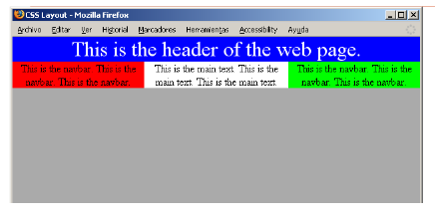
<html>
<head>
<style>
header{
background-color: blue;
color: white;
font-size: 10vh;
text-align: center;
}
div{
float: left;
width: 33.3%;
text-align: center;
font-size: 5vh;
}
.column1{
background-color: red;
}
.column3{
background-color: rgb(65, 247, 65);
}
</style>
</head><body>
<header>This is the header of the web page</header>
<div class="column1">
<p>This is the nav bar. This is the nav bar. This is the nav bar.</p>
</div>
<div class="column2">
<p>This is the main text. This is the main text. This is the main text.</p></div>
<div class="column3">
<p>This is the nav bar. This is the nav bar. This is the nav bar.</p>
</div></body></html>

- Use CSS code to create the following page: The page contains the following text – “Now paragraphs can have a border of their own”. The text should be positioned 100 pixels from the top and 40% from the right margin of the browser. The font is “Times Roman” in italics, the letter size 30 pixels and the color ABCDEF(h). The text is enclosed on all sides by a grooved border with the colors CC99CC, 99CCCC, CCCC99, C9C9C9 starting from the right border anti-clockwise respectively. The corresponding border thickness are 5 pt, 10 px, 2 cm, 1 in. The letter spacing should be 2 pixels and there should be a horizontal line through it.

<html>
<head>
<style>
div{
margin-top: 100px;
margin-left: 10px;
}

p{
letter-spacing: 2px;
text-decoration: line-through;
margin-right: 40%;
font-size: 30px;
color: #abcdef;
border-right: 5pt groove #cc99cc;
border-top: 10px groove #99CCCC;
border-bottom: 2cm groove #CCCC99;
border-left: 1in groove #C9C9C9;
}
</style>
</head>
<body>
<div>
<p>Now paragraphs can have a border of their own</p>
</div>
</body>
</html>

- Create three div elements, each with a width and height of 100px. On the first element, create slightly rounded corners using a border of 3px black and border-radius of 10px. On the second element, use a border of 3px black and increase the border-radius to 50px. On the third, use a border of 3px black and increase the border-radius to 100px. Make the background-color of each element a different color of your choosing. Inside each element, display the value of the border-radius in bold text.
<html>
<body>
<div style="width: 100px; height: 100px; border: 3px solid; border-radius: 10px; background-color: blueviolet;">
<h1 style="font-size: 20px; font-weight: bold;">Border Radius: 10PX</h1>
</div>
<div style="width: 100px; height: 100px; border: 3px solid; border-radius: 5px; background-color: rgb(226, 43, 119);">
<h1 style="font-size: 20px; font-weight: bold;">Border Radius: 5PX</h1>
</div>
<div style="width: 100px; height: 100px; border: 3px solid; border-radius: 100px; background-color: rgb(43, 159, 226);">
<h1 style="font-size: 20px; font-weight: bold; text-align: center;">Border Radius: 100PX</h1>
</div>
</body>
</html>

- Write the CSS rule to design page layout as shown below:

<html>
<body>
<header><img src="deil.jpg" alt="deitel" style="height: 100px; width: 100%; background-color: rgb(177, 177, 177);"></header>
<div style="float: right; background-color: rgb(212, 211, 211);">
<p style="font-size: 50px; font-weight: bold;">Corporate Training and Authoring</p></div>
<div style="border: 1px solid;"><p style="font-size: 30px; text-align: justify;">Deitel & Associates, Inc is an internationally recognised corporate training and authoring organisation
specializing in programming languages, internet/web technology, iphone and android app development and object
technology education. The company provides courses on Java, C++, c#, Visual Basic, C, internet
and web programming, object technology, iphone and android app development.
</p></div>
<div style="float: right; background-color: rgb(212, 211, 211);">
<p style="font-size: 50px; font-weight: bold;">Programming Books and Associates</p></div>
<div style="border: 1px solid;"><p style="font-size: 30px; text-align: justify;">Through its publishing partnership with Pearson,
Deitel & Associates, Inc. publishes leading-edge programming textbooks, professional books and interactive
web-based and DVD Live Lessons video courses.
</p></div>
</body>
</html>

- Create three div elements of varying colors, each with a width and height of 200px. On the first box, add a dimgrey box-shadow with a horizontal offset of 15px, a vertical offset of 15px and a blur radius of 20px. On the second box, add a dimgrey box-shadow with a horizontal offset of -15px, a vertical offset of -15px and a blur radius of 30px. On the third box, add a dimgrey box-shadow with a horizontal offset of 15px, a vertical offset of 15px and a blur radius of 10px.
<html>
<body>
<div style="width: 200px; height: 200px; box-shadow: 15px 15px 20px dimgrey; background-color: rgb(255, 190, 239);"></div>
<div style="width: 200px; height: 200px; box-shadow: -15px -15px 30px dimgrey; background-color: rgb(220, 190, 255);"></div>
<div style="width: 200px; height: 200px; box-shadow: 15px 15px 10px dimgrey; background-color: rgb(190, 229, 255);"></div>
</body>
</html>

- Write the CSS code to reproduce the following table using CSS positioning instead of <table> tag.
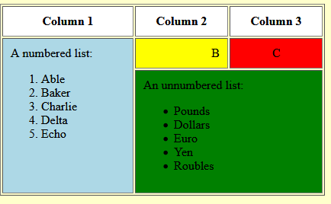
<html>
<body>
<div class="main-box" style="background-color:rgba(255, 246, 166, 0.705); border: 1px solid; display:flex; height: 75%; width: 75%;">
<div class="A-box" style="margin:1; width: 40%;">
<div style="background-color:rgb(255, 255, 255); margin:1; border: 1px solid; height: 10%;">
<p style="text-align:center; font-weight: bold; font-size: large;">Column 1</p>
</div>
<div style="background-color:lightblue; margin:1; border: 1px solid; height: 89%; ">
<p style="text-align:center; font-weight: bold; font-size: large;">A numbered list:
<ol style="list-style: decimal; align-content: center;">
<li>Able</li>
<li>Baker</li>
<li>Charlie</li>
<li>Delta</li>
<li>Echo</li>
</ol></p>
</div>
</div>
<div class="B-box" style="margin:1; width: 100%;">
<div style="background-color:rgb(255, 255, 255); margin:1; border: 1px solid; height: 10%; width: 50%; float:left" >
<p style="text-align:center; font-weight: bold; font-size: large;">Column 2</p>
</div>
<div style="background-color:rgb(255, 255, 255); margin:1; border: 1px solid; height: 10%;width: 49%; float:left" >
<p style="text-align:center; font-weight: bold; font-size: large;">Column 3</p>
</div>
<div style="background-color:yellow; margin:1; border: 1px solid; height: 10%; width: 50%; float:left" >
<p style="text-align:center; font-weight: bold; font-size: large;">B</p>
</div>
<div style="background-color:red; margin:1; border: 1px solid; height: 10%;width: 49%; float:left" >
<p style="text-align:center; font-weight: bold; font-size: large;">C</p>
</div>
<div style="background-color:green; margin:1; border: 1px solid; height: 78%; width: 99.5%; float:left" >
<p style="text-align:center; font-weight: bold; font-size: large;">A numbered list:
<ul>
<li>Pounds</li>
<li>Dollars</li>
<li>Euros</li>
<li>Yen</li>
<li>Roublers</li>
</ul></p>
</div>
</div>
</div>
</body>
</html>

- Write the CSS code to design a drop-down menu as shown below.
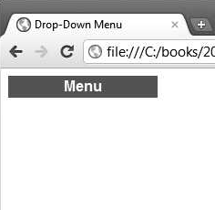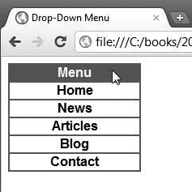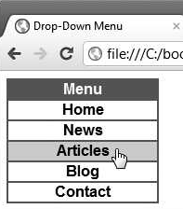

<html>
<head>
<style>
.main{
text-align: center;
width: 200px;
height: 50px;
background-color: rgb(90, 89, 89);
color: white;
font-size: 40px;
font-family: 'Lucida Sans', sans-serif;
position: inline block;
}

.dropdown{
text-align: center;
width: 198px;
height: 48px;
color: black;
border: 1px solid black;
font-size: 20px;
font-family: 'Lucida Sans', sans-serif;
font-weight: bold;
display: none;
position: relative;
}

.main:hover .dropdown{
display: block;
}

.dropdown:hover{
background-color: rgb(126, 105, 126);
cursor: pointer;
}
</style>
</head>
<body>
<div class="main">
<span>Menu</span>
<div class="dropdown"><p>Home</p></div>
<div class="dropdown"><p>News</p></div>
<div class="dropdown"><p>Articles</p></div>
<div class="dropdown"><p>Blog</p></div>
<div class="dropdown"><p>Contact</p></div>
</div>
</body>
</html>

- Write the CSS rule to display the content in a web page with two-column and three-column layout as shown below
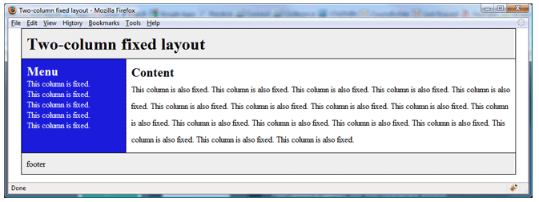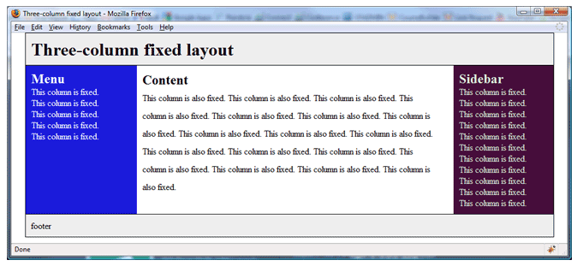

<html>
<head>
<style>
.header {
background-color: #dfdfdf;
padding: 20px;
text-align: center;
border: 1px solid;
}

.column {
float: left;
height: 50%;
}

.footer {
background-color: #dfdfdf;
padding: 20px;
text-align: center;
border: 1px solid;

}
</style>
</head>
<body>
<div class="header">Two-column fixed layout</div>
<div class = "row">
<div class="column" style="background-color: blue; width: 30%;]" >Menu<br>This is the menu<br>This is the menu<br>This is the menu<br>This is the menu</div>
<div class="column" style="background-color: rgb(255, 255, 255);width: 70%;">Content<br>This is the content<br>This is the content<br>This is the content<br>This is the content</div>
</div>
<div class="footer">footer</div>
</body>
</html>

<html>
<head>
<style>
.header {
background-color: #dfdfdf;
padding: 20px;
text-align: center;
border: 1px solid;
}

.column {
float: left;
height: 50%;
}

.footer {
background-color: #dfdfdf;
padding: 20px;
text-align: center;
border: 1px solid;
}
</style>
</head>
<body>
<div class="header">Two-column fixed layout</div>
<div class = "row">
<div class="column" style="background-color: blue; width: 20%; color: white;" >Menu<br>This is the menu<br>This is the menu<br>This is the menu<br>This is the menu</div>
<div class="column" style="background-color: white;width: 60%;">Content<br>This is the content<br>This is the content<br>This is the content<br>This is the content</div>
<div class="column" style="background-color: rgb(68, 13, 59); width: 20%; color: white;" >Sidebar<br>This is the menu<br>This is the sidebar<br>This is the sidebar<br>This is the sidebar</div>
</div>
<div class="footer">footer</div>
</body>
</html>

- Write the CSS code for the below output.
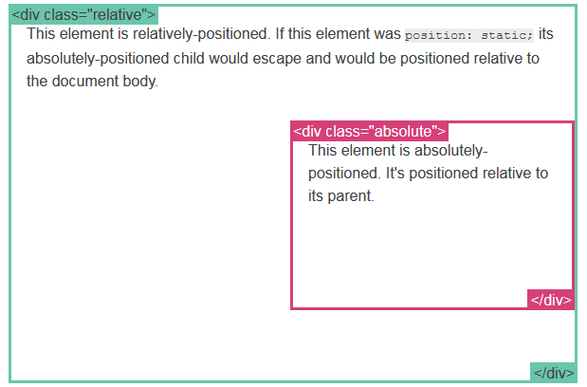

<html>
<head>
<style>
.box1{
position: relative;
border: 2px solid cyan;
width: 100%;
height: 500px
}

.box2{
position: absolute;
border: 2px solid plum;
width: 25%;
height: 100px;
bottom: 80px;
right: 0;
}
</style>
</head>
<body>
<div class="box1">
<div class="box2"></div>
</div>
</body>
</html>

- Write a CSS code to design a web page as shown below using layout and positioning rules:
